

**GOMC Capstone**

**User Guide**

_________________________________________________________________________________________________________

Version 0.4

December 3, 2017

# **Prepared by:** Caleb Latimer

# Ahmed Taher

Muamer Besic

**REVISION HISTORY**

|  |  |  |  |
| --- | --- | --- | --- |
| **Version**  **#** | **Implemented**  **By** | **Revision**  **Date** | **Scope of Change** |
| 0.1 | Caleb L | 11/30/17 | Cover, Version History, Table of Contents Skeleton, Footer, Page-Count Sections 1 – 4 Complete |
| 0.2 | Caleb L | 12/1/17 | 4.1-9.2 Complete, Images of all pages added, sent to team and TA for review and feedback |
| 0.3 | Caleb L | 12/3/17 | Considered general feedback, adjusted numbering, proofread |
| 0.4 | Muamer B | 12/3/17 | Edited whole document when it comes to grammar, formatting changes, additions as well as inputted up-to-date screenshots |
|  |  |  |  |
|  |  |  |  |
|  |  |  |  |
|  |  |  |  |

**Table of Contents**

**1. Overview ................................................................................................................... 4**

**2. GOMC ....................................................................................................................... 4**

**3. Features ................................................................................................................... 5**

**4. Downloads ……........................................................................................................ 6**

4.1 More Downloads ........................................................................................... 7

4.2 More Examples ............................................................................................. 8

4.3 Registration ................................................................................................... 9

**5. Documentation ……............................................................................................... 10**

5.1 XML Configuration ...................................................................................... 11

**6. Publications …….................................................................................................... 12**

**7. About ……............................................................................................................... 13**

**8. Footer ...........……................................................................................................... 14**

8.1 Terms & Conditions .................................................................................... 14

8.2 Site Map ...................................................................................................... 15

8.3 Privacy Policy .............................................................................................. 15

8.4 FAQ ............................................................................................................. 16

**9. Admin ...................................................................................................................... 17**

9.1 Login ........................................................................................................... 17

9.2 Admin page ................................................................................................. 18

**1. Overview**

The GOMC User Guide is designed to detail the full intended UX for the GOMC-Capstone web application. In the following sections of this document, you will find detailed descriptions of content and the intended flow that the application is designed for.

**2. GOMC**

The GOMC page in the application is the main landing page. Upon navigation to the domain, the user will load this page.

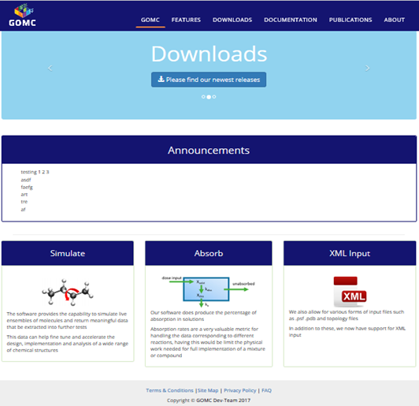

Contained within is the navigation bar that is consistent throughout each page consisting of links to all the parent pages. Also, we have the footer containing links to the terms of service, privacy, site map, and FAQ (frequently asked questions).

The content of the GOMC page serves to highlight key features of the website and present attractive data to the user. The rotating cell at the top has a brief description of GOMC and buttons that link directly to the downloadable content and documentation. Immediately under that, the user is presented with key announcements of relevant information.

Further under that, the main components offered from the software are presented with a brief description of their features.

**3. Features**

The features page contains a simples list of features native to the GOMC software. It has pictures next to descriptions that are fairly detailed about parts of the software that the user should find appealing to their need.

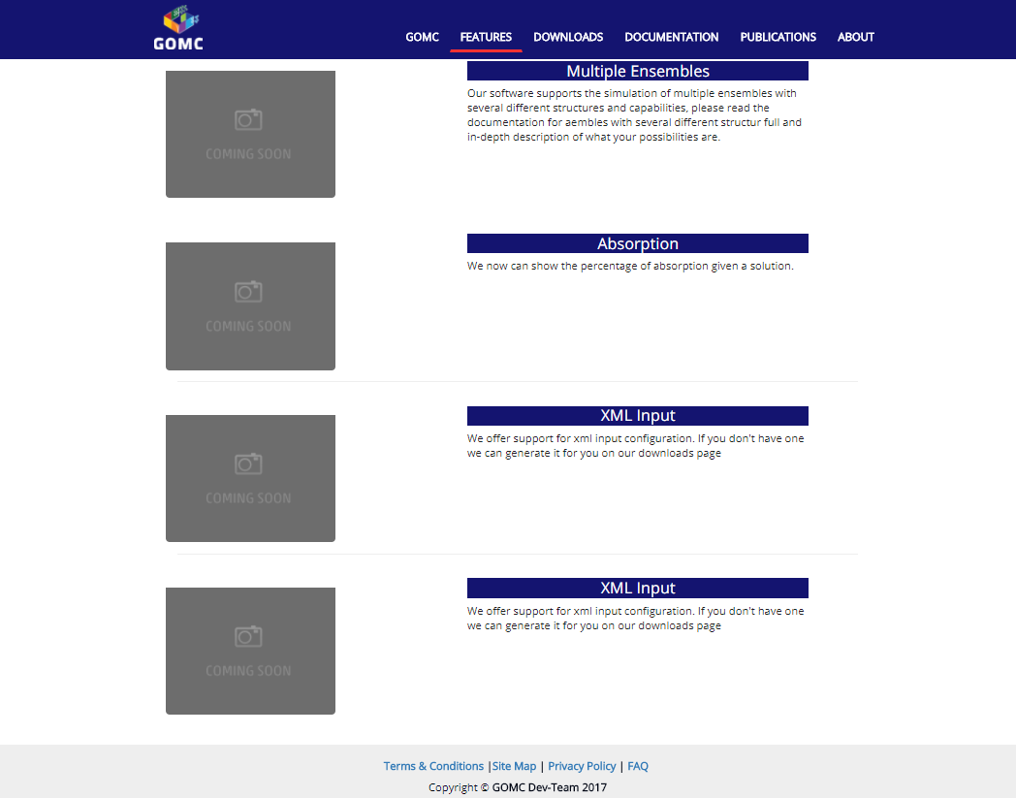

The list is arranged in priority with the most appealing features at the top and some of the older, more generic features towards the bottom.

**4. Downloads**

The downloads page has the goal of presenting the downloads information to the user to enable them to download zips of the software as well as coding examples from the website without any need for navigating to the repo and downloading the zip or cloning.

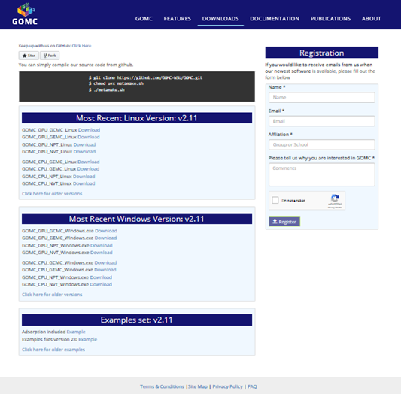

The secondary goal is user registration where a user is presented with a small form that they may opt into to register for email notifications about new posts or potentially new downloads. Both parts will be detailed in this section.

**4.1 More Downloads**

To address compatibility issues, we aim to support multiple versions of the software. Clicking "Click here for older versions" link will navigate the user to the page below which will support all the older versions of the available downloads of the software.

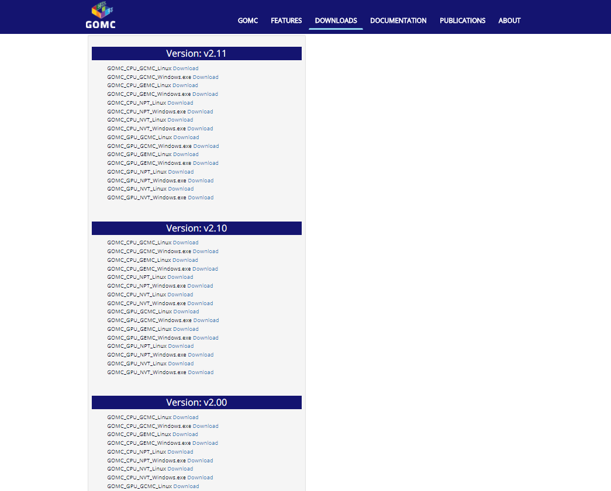

**4.2 More Examples**

Further, we aim to address this issue with older examples as well by incorporating the same availability.

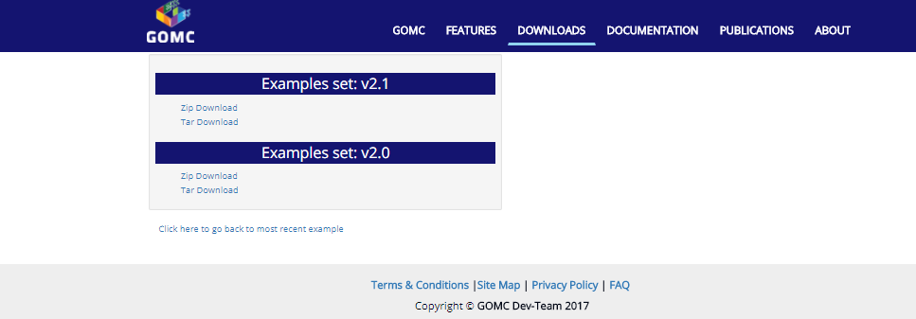

**4.3 Registration**

To get closer to our user base and gain feedback, we allow users to register onto our mailing list. By filling out the form and captcha as shown below, a user can self-enroll. All fields and the captcha are required to prevent spamming.

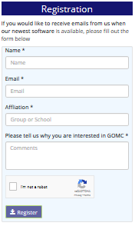

**5. Documentation**

The Documentation page serves three main goals:

* Present a means to access the official documentation
* Provide a subset of tutorial videos and a means of accessing more
* Allow the user access to the XML Configuration Form

The documentation is presented in both Latex formatted HTML with some dynamic scrolling features as well as a PDF that opens in a new tab for quick access.

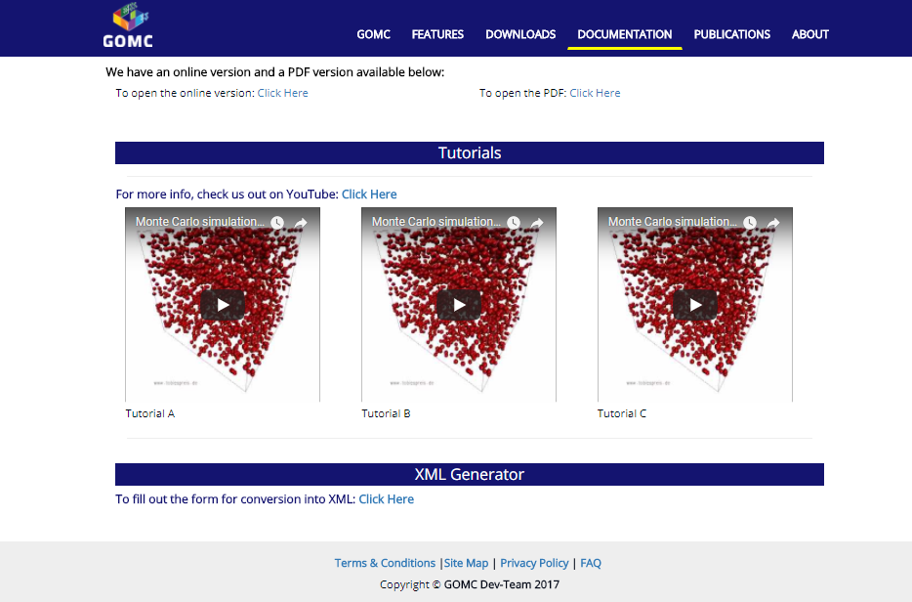

With the tutorials, we aim to cater to users who have a better mindset when provided with visual representations (YouTube videos). We also have a link to the YouTube playlist (though it is not active now) for fast access to all the videos associated.

In the following subsection, we will discuss in further detail about the purpose of the XML config form.

**5.1 XML Configuration**

The XML configuration form presents the user with a four-step form from which they will receive a downloadable configuration file that is compatible with the GOMC software.

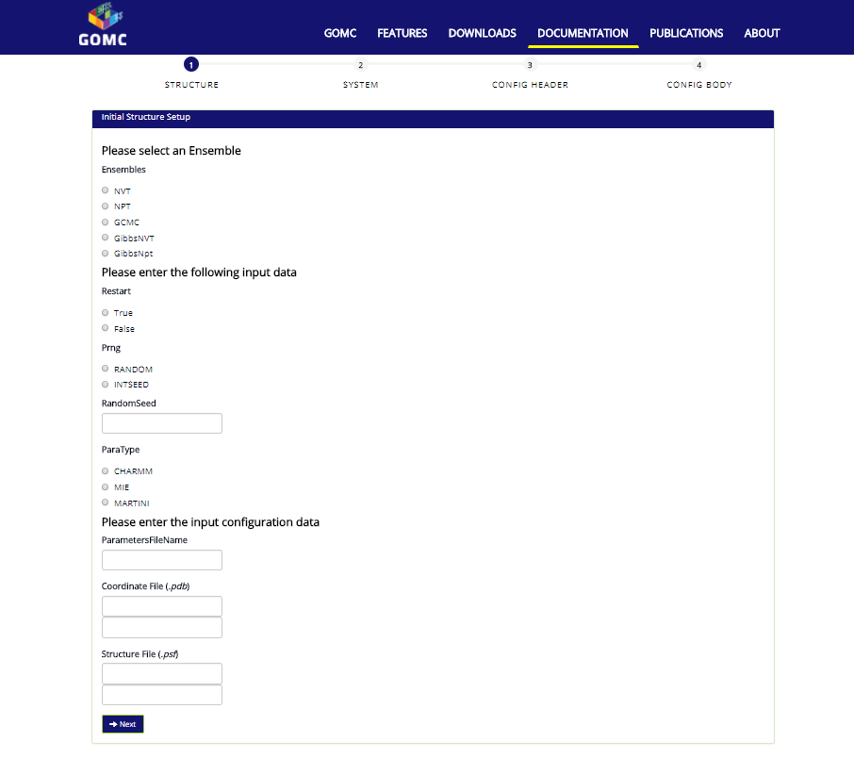

The multi-part form has client-side validation which will let the user know of any errors that may occur while filling out this form.

**6. Publications**

On this page, the user is presented with a table style list showing the related publications of the research team. With this, associated images and links to online resources are also made available.

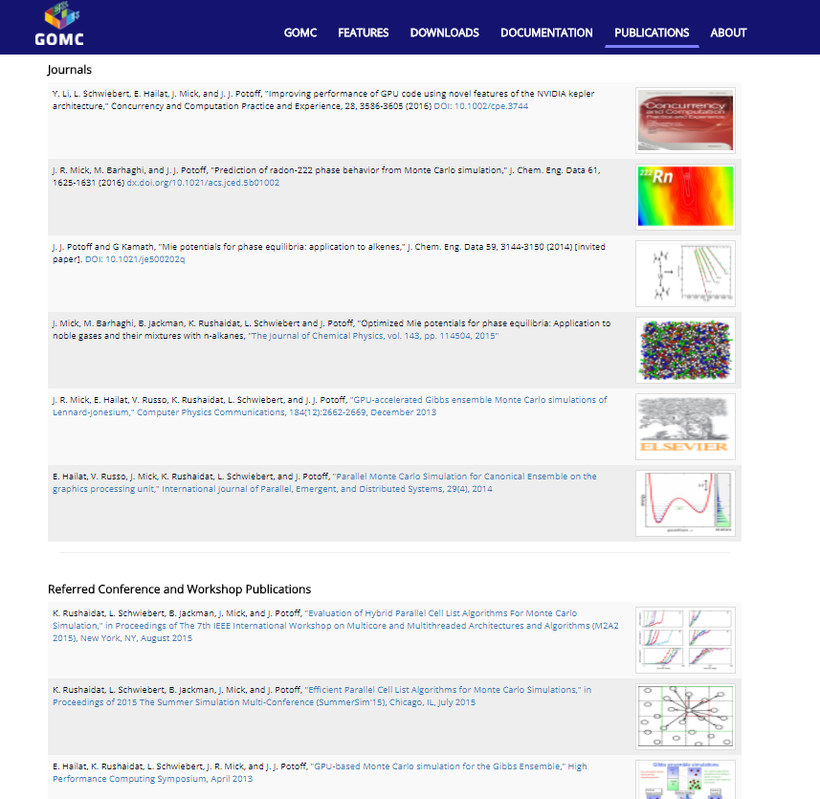

**7. About**

The faculty, undergraduate/graduate students, associated alumni, benefactors, and supporters are given recognition on this page. This presents a face of the GOMC project to the user.

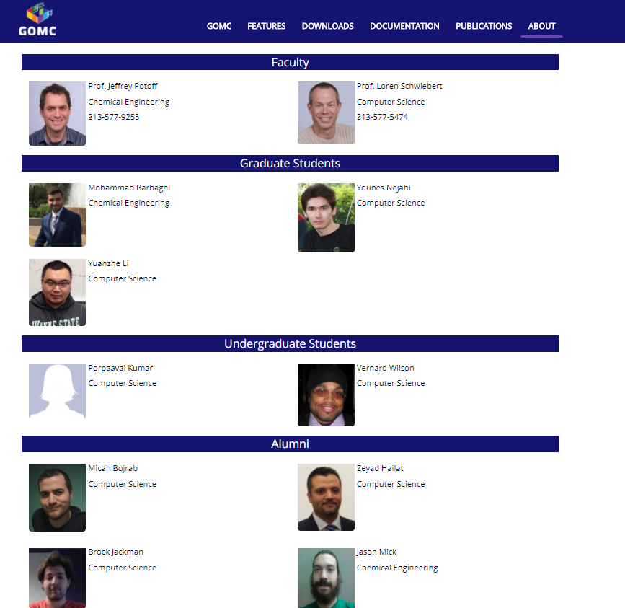

**8. Footer**

This section will detail the footer pages being the Terms & Conditions, Site Map, Privacy Policy, and FAQ sections. This footer of page links is consistent across all pages and each of them come with their own separate in-browser documentation view.



**8.1 Terms & Conditions**

This section presents the terms of service to the user in a standard fashion:

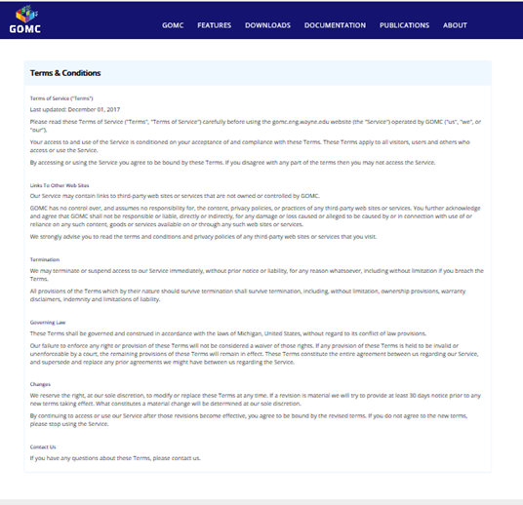

**8.2 Site Map**

A site map is included for search engine optimization as well as a collection of available pages and links to the standard user.

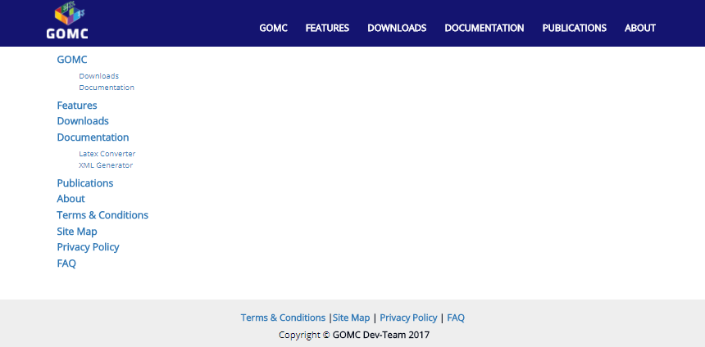

**8.3 Privacy Policy**

Our Privacy Policy is presented below:

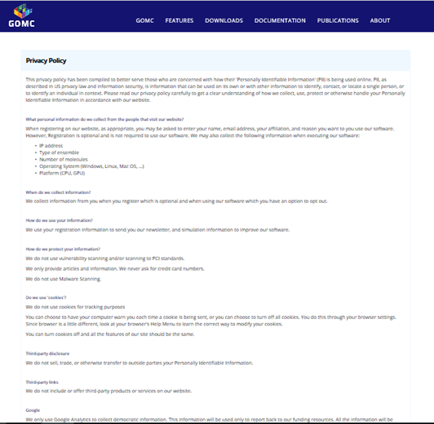

**8.4 FAQ**

Based on user feedback, the most frequently asked questions across our mediums are addressed with answers here.

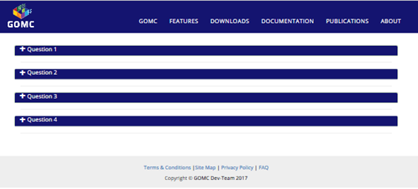

**9. Admin**

The administrator page is restricted from conventional users and is not included in any direct link, site map, or normal flow. To access the page, the user must use the extension /home/admin or /home/login to navigate to the login page and be authenticated of their admin credentials.

Adding new administrators, changing administrator credentials, and removing/resetting credentials will all be detailed in our deployment document. In the subsections that follow, we will discuss the different actions that are taken on the login and administrator pages as well as describe their uses.

**9.1 Login**

The login screen is a simple form with two fields and a captcha. A user will be blocked from attempting to login after three failed attempts. Once logged in, a valid session is started and the user will remain logged in until they log out or their session expires. Once logged in, further access to the Login page results in a redirect to the admin page.

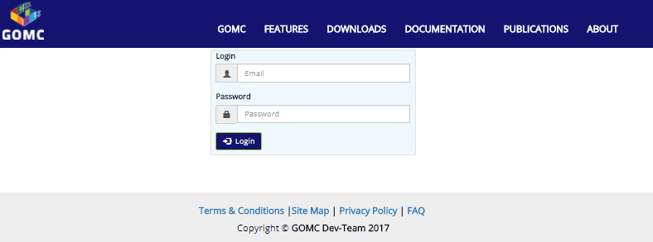

**9.2 Admin page**

The administrator page presents some levels of control over the website content as well as some meaningful data about use, logging, and the ability to upload new documentation to the website.

Firstly, we have a logout button at the top of the panel allowing for the admin to logout. Within the panel, the user can manually enter a new announcement to the home page, preview the new announcement created before they post it, and it also comes with support for HTML input. Having this support will allow embedding of HTML, links, and will increase the range of data that an admin is able to present. On top of that, we support the ability to clear announcements in the text area as well as remove current announcements with a confirmation prompt just to be safe.

In the next area, we have a download link for some dynamic server logs to show the status of how the database is handling things. This should help the user with troubleshooting or making an action plan should the need arise. In addition to that, we have a table for some basic statistical data which will keep the user quickly informed of important user data such as views, clicks, downloads, etc.

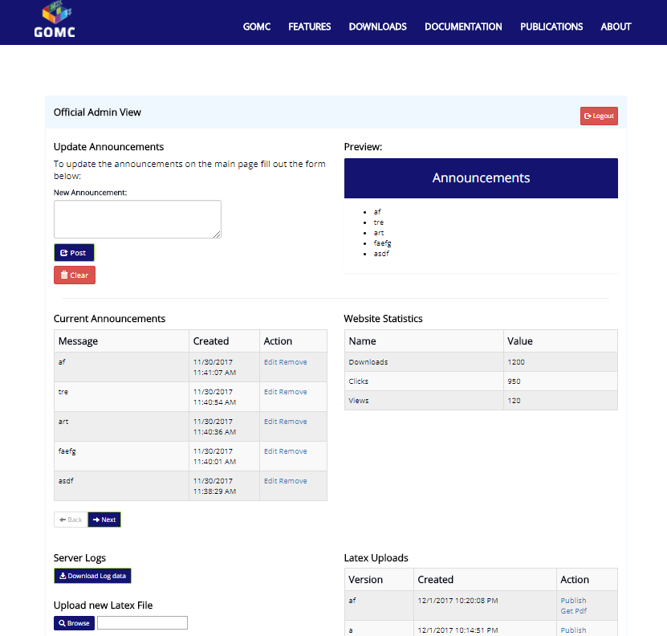

Beyond that, we have the documentation upload area which allows the user to upload a latex file and publish it directly to the website to replace the current documentation. Performing the upload requires a LaTeX file and a version name to keep track of that file.

Finally, we have the "Registered User Table" which allows the admin to paginate through the store of user data. The table is searchable, sortable, and offers Regex based searching as well to streamline the process of finding some registered user data from the website.

